PS3 Unbeveled

The PS3 has a large bevel on its surface making it both difficult and a hazard to stack any items on it.

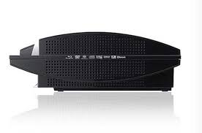

Neither the PS2 nor the PS4 has this problem.

The easiest and most efficient way to solve this problem would be with a 3d printer.

Related Companies

Play Station

Game Stop

Konica minolata

Sony

Ubisoft

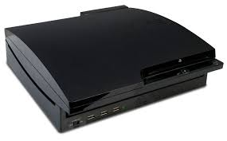

**Key Words**

Bevel

PS3

Design

3d Print

Info

Creator: Skyler Simpson

Phone # 803-493-5480

Email: Sjskyler27@gmail.com

School: Fort Mill High School

[Address](https://www.google.com/search?safe=strict&q=fort+mill+high+school+address&stick=H4sIAAAAAAAAAOPgE-LSz9U3MDczryhI0pLNTrbSz8lPTizJzM-DM6wSU1KKUouLAakAyWwtAAAA&sa=X&ved=0ahUKEwi__tHR4ILZAhWFtlMKHWUsD18Q6BMIkgEwEA): 215 N U.S. 21 Bypass, Fort Mill, SC 29715

[Phone](https://www.google.com/search?safe=strict&q=fort+mill+high+school+phone&sa=X&ved=0ahUKEwi__tHR4ILZAhWFtlMKHWUsD18Q6BMIngEwEg): [(803) 548-1900](https://www.google.com/search?q=fmhs&oq=fmhs&aqs=chrome..69i60j69i57j0l3j69i65.2568j0j7&sourceid=chrome&ie=UTF-8)

Teacher: Patrick Lions

